**CM 1900- Intelligent Machines Inspirational Project**

**PROJECT PROPOSAL REPORT**

**Level 01**

**DualPlay**

**The Ultimate Two-Side Air Hockey Experience with an Intelligent Opponent**

Examiner - Mr. B. H. Sudantha

**Submitted by:**

**225511E - Epasinghe S.K**

225520F - Helapalla K.O.R.I

225507X - Dhananjana R.A

225529P - Nimraka T.M.N

225537M - Randinu L.L

Bachelor of Artificial Intelligence

Faculty of Information Technology

University of Moratuwa

**Table of Contents**

1. Introduction 3

1.1 Problem in Brief 3

1.2 Significance of study 3

1.3 Aim and Objectives 3

2. Literature Study 4

3. Proposed Solution 5

3.1 Features of the Proposed Solution 5

3.2 Nature of the Solution 7

3.3 Solution Design 8

3.4 Resources 10

3.5 Workload Matrix 12

4. References 13

# **Introduction**

These days, as technology affects every part of our lives, hardware and entertainment combine to create a world of creative possibilities. The main attempt presented by this project is the creation of an independent physical game that blends traditional gaming with modern technology. Designed specifically to give players a dynamic experience. Our game named “DualPlay” uses robotics, sensors, and intelligent algorithms to deliver a level of excitement and engagement never seen before.

## **Problem in Brief**

When it comes to the traditional model of computer gaming, it involves playing video games through a computer interface without interacting with other players. Playing these kinds of games for extended periods of time can have negative impacts on social dynamics and physical health. On the other hand, multiplayer, traditional physical games require the presence of another player. In response to these worries, we suggest incorporating the hybrid game "Dual Play," which aims to promote player interaction while also providing independent player-versus-artificial intelligence (AI) features. This invention reduces the limitations that come with playing traditional games by enabling players to engage in gameplay without the need for human players.

## **Significance of study**

This game promotes innovation in gaming technology by providing the player with a hybrid option of playing against a player as well as an autonomous opponent, promoting social interactions while providing the ability to play the game without a human opponent when required. This defines the adaptability of this game to provide entertainment irrespective of the situation. “DualPlay” promotes physical interaction of a player omitting the issues in the traditional computer games.

## **Aim and Objectives**

**Aim**

The project aims to create an engaging and interactive multiplayer table game that combines the excitement of air hockey with innovative features such as autonomous gameplay modes and customizable gameplay options. The game, titled " DualPlay: The Ultimate Two-Side Air Hockey Experience with an Intelligent Opponent", will provide players with a unique and enjoyable gaming experience that encourages social interaction, strategic thinking, and friendly competition.

**Objectives**

* To design and build an upgraded version of air hockey game with two game modes: Human vs Human and Human vs Intelligent system.
* To provide an entertaining and enjoyable game that promotes relaxation and mental stress relief.
* To Create a multiplayer experience that encourages social interaction and friendly competition among players.
* To encourage Human Players to Engage in Duels, Challenging and Defeating the Intelligent System player for Ultimate Victory.
* To implement autonomous gameplay modes to accommodate varying numbers of players and ensure an enjoyable experience regardless of player availability.
* To enhance gameplay with visual cues through LCD displays to indicate scores and an integrated sound system for an immersive experience.
* To develop user friendly interfaces for selecting game modes, selecting difficult levels, selecting number of rounds, and keeping track of scores.

# **Literature Study**

Air Hockey is an interactive and an exciting game for individuals to play during their free time to entertain themselves. It is table game in which two players attempt to score points by using a handheld paddle to shoot a plastic disk across a surface with minimal friction into the opponent's goal [1]. But this game limits at least two players to be present in order to play a game. DualPlay stands out as a unique game which can control one paddle autonomously using computer vision techniques. This can eliminate the limitation where two or more players must be present in order to play a game successfully since only one player can play by controlling the designated paddle while the other paddle functions autonomously.

Players in an Air Hockey game does not receive points or prizes for winning. However, with DualPlay, a player's point scoring may be easily detected and recorded on the LCD screen thanks to the IR break beam sensor. When the game is over, it will also play a victory sound to cheer up the winner.

# **Proposed Solution**

Our proposed solution, the DualPlay air hockey game, represents a notable advancement from traditional air hockey games. One key feature is the option for human players to compete against either another human player or an intelligent system. This intelligent system utilizes computer vision with OpenCV color tracking and contours detection to dynamically track the ball's movements to get the real-time location of the ball, providing a substantial challenge for human players. Human interaction is facilitated through a user-friendly remote control with three buttons for easy paddle manipulation. Our system sets itself apart with well-organized game modes with different difficulty levels, a real-time score updating system, and innovative ball redeploying mechanisms, establishing the DualPlay system as a distinguished and engaging choice in the air hockey market.

## **Features of the Proposed Solution**

1. **Game Initialization:** The LED displays show the main menu with the available gameplay modes and difficulty levels.
2. **Mode Selection:** Player(s) approaches the table and selects their desired gameplay mode using the keypad on the table.

• Available modes include,

* Human vs Intelligent system (1v1)
* Human vs Human (1v1)

• The system will then prompt for the number of points required for a player to win.

1. **Player Setup:**

• Human vs Intelligent system (1v1) – A human player takes their position at one side of the table and controls their paddle using the corresponding wired remote. The opposing side is autonomously guided by the intelligent system.

• Human vs Human (1v1) – Both human players take their respective positions at the table and control their paddles using individual wired remotes for each side.

1. **Ball Placement:** The ball will be automatically launched onto the table from one player's side, initiating the start of the game.
2. **Game Start:**

• Players use their remote controls to move their paddles and start hitting the ball. In cases where the intelligent system is participating, it autonomously guides its paddle by tracking the ball’s position.

• The game begins, and players try to hit the ball into their opponent's goal to score points.

1. **Scoring a Goal:**

• When a player successfully hits the ball into their opponent's goal, a point is scored.

• The LCD displays update the score, and the sound system emits a celebratory sound to mark the achievement.

1. **Ball Reset:**

• Following a scored point, the ball is automatically launched onto the table from the side of the player who did not score the point.

1. **Score Tracking:**

• The LCD displays update the scores for each player in real-time.

• Players can easily see the current score without interrupting the game.

1. **Autonomous Gameplay (Human vs Intelligent system (1v1)):**

• Here, the system controls one side of the table.

•The Intelligent opponent(system) uses computer vision to track the ball’s position to move the paddle correctly to provide a challenge to the player.

1. **Match Completion:**

• The game proceeds until one player achieves the predefined winning score.

1. **Game Over:**

• The game concludes when a player wins the match.

• The LCD displays show the final scores and show who is the winner, and the sound system produces a victory sound.

1. **Reset for New Match:**

• Players can choose to start a new match, change modes, or end the session.

1. **Power Down:**

• When the gaming session is complete, the game can be powered down.

• Scores and settings are reset for the next session.

## **Nature of the Solution**

Input

Process

Output

If the system is playing, Track the color of the ball using computer vision algorithms to get the real-time location of the ball and control the intelligent system’s paddle according to the location of the ball. If the human is playing, control the paddle according to user inputs.

**Raspberry pi 3 model B**

Real-time video capture

Camera

Control the paddle

Belt driven linear paddle system with Nema 17 stepper motor and a solenoid lock

User press push buttons

Push Buttons

(Wired Remote)

Give a signal when the game starts with the game mode and difficulty level or when a round starts

Display game modes, difficulty levels and

Mode selection LCD screen

**Arduino Mega**

User input

Select the game mode, difficulty level and number of rounds according to the user input.

number of rounds

Keypad

Belt driven linear paddle system with Nema 17 stepper motor and a solenoid lock

User press push buttons

Push Buttons

(Wired Remote)

Control the user's paddle based on input received from the push buttons on the remotes.

Control the paddle

IR Break Beam Sensor

When the ball enters a hole, update the scores on the LCD screens accordingly and activate the buzzer to play the round-winning sound.

Game score updating system with lcd screens and buzzers, and ball redeploy system with servo motors

Whether the ball enters a hole or not

Update scores and redeploy the ball

**Figure 01: Block diagram of the input, process, and output**

## **Solution Design**

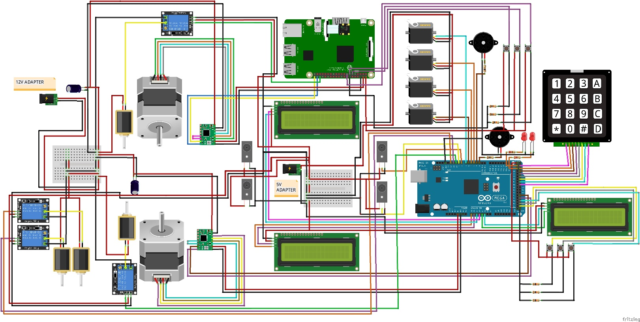

**Figure 02: Connection of components**

Scores

Paddle

Ball

Hole

Camera

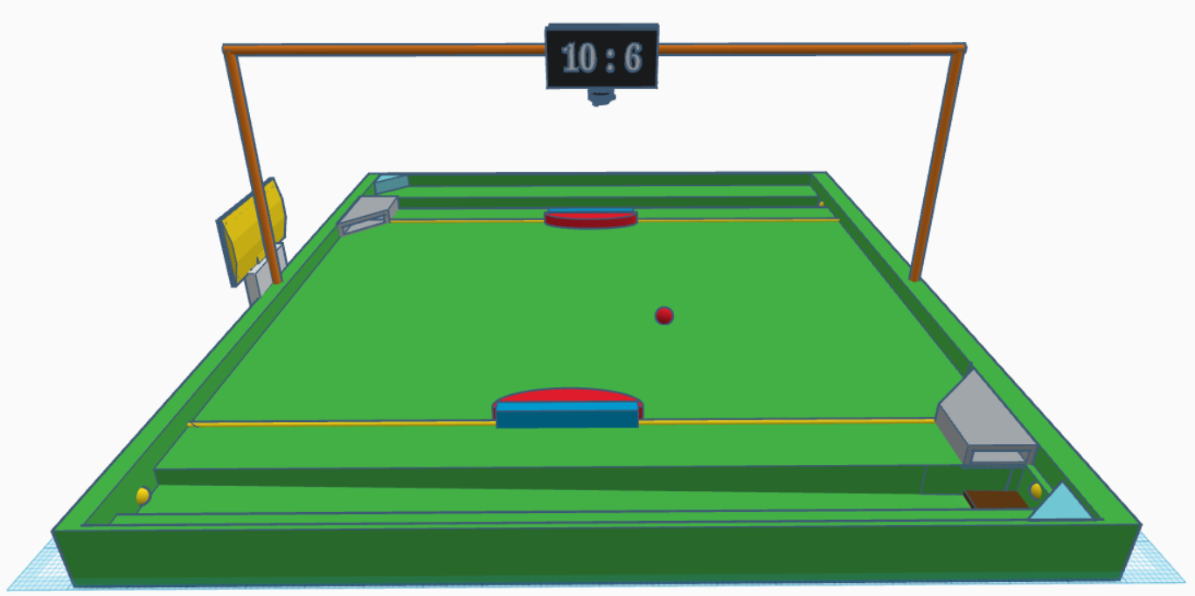

50 cm

50 cm

IR Break Beam Sensor

Ball Redeploy Mechanism

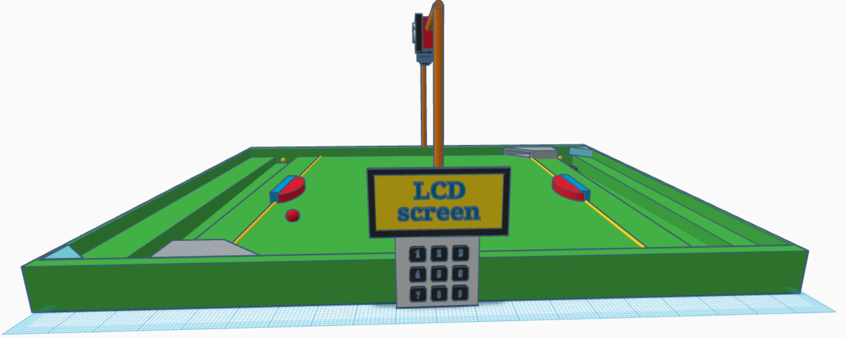

Mode Selection LCD Screen

Keypad

**Figure 03 & 04: A graphical or 3D view of the solution.**

NEMA 17 stepper motor

Belt

Paddle

Pulley

**Figure 05: Paddle move mechanism** [2]**.**

## **Resources**

|  |  |  |  |
| --- | --- | --- | --- |
| Item name | Price | No. of items | Total  (LKR) |
| Raspberry Pi 3 Model B | 21650 | 1 | 21650 |
| Arduino Mega | 5800 | 1 | 5800 |
| Kingston MicroSD 32GB | 1850 | 1 | 1850 |
| 5V 3A Micro USB Power Adapter (Raspberry Pi) | 1050 | 1 | 1050 |
| Tactile Push Button 12x12x7.3mm | 20 | 6 | 120 |
| Servo Motor Plastic Wheel MG90 Full Set | 450 | 2 | 900 |
| Servo Motor Plastic Wheel SG90 Full Set Normal | 380 | 2 | 760 |
| 4x3 Matrix Array Keypad Switch Module | 750 | 1 | 750 |
| 1602 16x2 Blue Backlight LCD Display | 360 | 3 | 1080 |
| IIC/I2C/TWI/SPI Serial Interface Board Module Port for 1602 LCD Display PCF8574T | 230 | 3 | 690 |
| Camera Module v1.3 5MP 1080p 720p for Raspberry Pi 3 and 2 | 1350 | 1 | 1350 |
| 15-Pin Ribbon Cable 50cm Flex CSI Raspberry Pi Camera | 100 | 1 | 100 |
| 17HS8401 NEMA 17 Stepper with wire 0.52Nm (D Shaft 5mm) | 2900 | 2 | 5800 |
| 1Kg 3D Printer Filament | 5000 | 1 | 5000 |
| A4988 Stepper Motor Driver for CNC 3D Printer | 350 | 2 | 700 |
| 30 Teeth Timing Pulley (5mm Bore) | 560 | 2 | 1120 |
| Brown GT2 6mm Timing Belt (Anti-Slip Toothed Cloth, Rubber with Fiberglass) Per 1m | 430 | 2.5m | 1075 |
| IR Break Beam Sensor 5mm LED | 690 | 2 | 1380 |
| Plywood board (50cm * 50cm) | 1000 | 1 | 1000 |
| Solenoid switch | 1450 | 4 | 5800 |
| 2020 t slot aluminum extrusion 1m | 2450 | 1 | 2450 |
| Linear system paddle and supporters | 3000 | 2 | 6000 |
| 5VDC 2 Way 2 Channel Relay Module with Coupling Protection | 300 | 2 | 600 |
| SHD2210 Active Piezo Buzzer 3-24VDC 22x10mm | 170 | 2 | 340 |
| 12V 20A SMPS Power Supply Metal Casing | 3100 | 1 | 3100 |
| Net Amount | **69390 LKR** | | |

## **3.5 Workload Matrix**

|  |  |
| --- | --- |
| Registration Number | Assigned Responsibilities |
| 225511E | Program servo motors for ball lift mechanism and program solenoid to strike the ball. (Ball redeploy mechanism in one side)  Program two push buttons to get user inputs and program Nema 17 motor for the human play paddle movement according to push button inputs. (One side)  Program the mode selection lcd screen to show “A match is ongoing” during a match. |
| 225520F | Program the camera to detect and get the location of the ball and program Nema 17 motor for the system’s paddle movement and program solenoid with relay module to strike the ball for system play.  Program two lcd screens, LEDs and buzzers to show the winner and the looser after a match.  Make the connection between Arduino and raspberry pi. |
| 225507X | Program one push button to get user input and program solenoid with relay module to strike the ball for the human play according to push button inputs. (One side)  Program the keypad and mode selection lcd screen to select game modes, difficulty level and to get number of rounds from the user and program LEDs and buzzers to indicate the start of a match. |
| 225529P | Program two push buttons to get user inputs and program Nema 17 motor for the human play paddle movement according to push button inputs. (One side)  Program servo motors for ball lift mechanism and program solenoid to strike the ball. (Ball redeploy mechanism in one side)  Program IR beam break sensor in one side. |
| 225537M | Program IR beam break sensors, two lcd screens to display points of players and program buzzers and LEDs to show a point is scored by a player (One side)  Program one push button to get user input and program solenoid with relay module to strike the ball for the human play paddle according to push button inputs. (One side) |

# **4. References**

|  |  |
| --- | --- |
| [1] | "merriam-webster," 2 2 2024. [Online]. Available: https://www.merriam-webster.com/dictionary/air%20hockey. |
| [2] | "open builds part store," 10 1 2024. [Online]. Available: https://openbuildspartstore.com/v-slot-nema-17-linear-actuator-bundle-belt-driven/ . |
| [3] | A. TEAM, "arduino.cc," [Online]. Available: https://blog.arduino.cc/2018/10/29/linear-movement-with-arduino-and-3d-printing/. [Accessed 10 1 2024]. |
| [4] | Felipe, "Computer vision engineer," [Online]. Available: https://www.youtube.com/watch?v=eDIj5LuIL4A . [Accessed 27 12 2023]. |
| [5] | "Mechanical Design Masters," [Online]. Available: https://youtu.be/ve9M8d6KfdI?si=8PxCvQbe-xPVnI0p. [Accessed 20 12 2023]. |
| [6] | "OpenCV," [Online]. Available: https://docs.opencv.org/3.4/df/d9d/tutorial_py_colorspaces.html. [Accessed 27 12 2023]. |
| [7] | "OpenCV," [Online]. Available: https://docs.opencv.org/3.4/da/d97/tutorial_threshold_inRange.html. [Accessed 27 12 2023]. |
| [8] | "OpenCV," [Online]. Available: https://docs.opencv.org/4.x/d3/d05/tutorial_py_table_of_contents_contours.html. [Accessed 27 12 2023]. |